

Course | : | Advanced Diploma in Information Technology
Module title | : | Advanced Software Design 4
Module Code | : | ASSDX4A
Assessment | : | Assessment 3: CI, CD
Lecturer | : | Mr. T Shongwe

Roles | Initials | Surname | Student Number
Git Lead | T | Phakani | 222783311
CI Engineer | T | Rambau | 223549630
Deployment Lead | N | Lubisi | 223293415

Bug report table
Bug ID | Bug Description | Function | Expected Result | Actual Result | Solution
BUG #1 | Weight calculation is swapped | calculateFinalMark() | Semester mark should be 40% and exam should be 60% | Nothing happens when clicked | Changed to: semester × 0.4 + exam × 0.6
BUG #2 | Grade boundaries are incorrect | determineGrade() | Distinction should be >= 80 | Page loads slowly | Corrected to: >=80, >=70, >=60, >=50
BUG #3 | Admission check uses wrong threshold | hasExamAdmission() | Should require >= 40 for exam admission | Incorrect total appears | Changed condition to semesterMark >= 40
BUG #4 | Average calculation has off-by-one error | calculateClassAverage() | Divides by (marks.length + 1) instead of marks.length | Broken image icon appears | Changed divisor to marks.length
BUG #5 | Pass rate calculation divides by total instead of multiplying by 100 | calculatePassRate() | Returns the pass rate multiplied by 100 | calculation divides by total | Changed condition to mark >= 50
BUG #6 | Highest mark finder returns lowest instead | findHighestMark() | Return the highest mark | returns the lowest mark | Changed comparison to marks[i] > highest
BUG #7 | Supplementary exam eligibility check is wrong | qualifiesForSupplementary() | Checks from 46 to 49 | Checks from 40 to 44 | Changed to: finalMark >= 45 && finalMark <= 49
BUG #8 | Mark validation allows marks over 100 and below 0 | isValidMark() | returns True when parsed value is 0-100 | returns true for every value | Changed to: mark >= 0 && mark <= 100
BUG #9 | Report shows "ADMITTED" even when student is NOT admitted | generateStudentReport() | Shows "Admitted" where is admitted | Report shows "Admitted" when should be false | Removed the ! negation operator

Screenshots
Bug | Screenshots
#1
#2 | 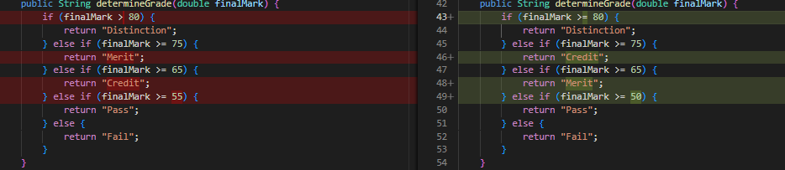
#3
#4
#5
#6
#7
#8
#9

